**Lab 8: Modeling Neuronal Spikes**

# Neurons are digital messengers.

We discussed in lecture how neurons use electrical signals to transmit information and make decisions, processes that underlie everything from unconscious muscle activity (“motor activity”) to the rich thoughts and feelings that make us human (“cognitive activity”). Neurons are highly specialized cells, and they have a finely tuned system of ion channels and transporters that do the molecular jobs to make the electrical signals work.

The structure of a neuron is designed to accept *input* signals from certain neurons and to send *output* signals to other neurons. Input is received via multiple *dendrites* at one end of the cell, and output is sent from *axon terminals* at the other end of the cell.

When one neuron sends another neuron a message, the “sender” passes small molecules called *neurotransmitters* from one of its axon terminals to a dendrite of the “recipient.” However, if a neuron can be said to “think,” then it thinks in terms of electricity, not neurotransmitters. This means that they keep track of their concentrations of positively and negatively charged ions, and changes in the electrical state of the cell trigger all-or-none activation responses.

When one neuron sends neurotransmitters to another, we can think of the sender as effectively handing the other neuron a “key,” which temporarily opens ion-channel proteins in the membrane of the recipient. Charged ions then flow through these channels, and the neuron realizes it’s received a signal when its electrical voltage changes. If the voltage changes enough, a cell-wide electrical activation called an *action potential* will ensue.

# A Simple Model for a Single Neuron

In class we discussed the Hodgkin-Huxley model of neuronal activation. This model was an incredible achievement, and a very accurate description of neuronal activity. However, it is very complex and difficult to analyze. For that reason, simpler approximate models were created to provide a more intuitive understanding of the system. One of the most popular of these simplified models is the FitzHugh-Nagumo model.

As you know, the term “voltage” refers to the electrical potential caused by differences between concentrations of positive and negative ions. The first differential equation in the *Fitzhugh-Nagumo* model is for voltage, *V*:

$$\frac{dV}{dt}=-V^{3}+1.2V^{2}-0.2V-C+I$$

$$\frac{dC}{dt}=0.002(V-C)$$

The second equation is for a slower inhibitory response which can be characterized by its channel “openness,” *C*. This response opposes increases in voltage; more specifically, it tries to decrease the voltage to zero. In the first equation, *I* represents the *input* to the cell.

The Fitzhugh-Nagumo model studies the behavior of a single neuron rather than that of a collection of neurons. In many cases, a neuron will receive lots of input signals from other neurons. However initially, for simplicity, **we will treat the input to this neuron as a constant**. Can you think of a physical situation in which our assumption might be reasonable?

During sleep or meditation

The first differential equation tells us that the rate of change of voltage is highly dependent on the current voltage. Mathematically, this is because the equation involves nonlinear terms—there’s a cubic term and a square term present.

The second differential equation is simpler. What is the condition for *C* not to change in time? Does this depend on the input?

C is dependent on voltage, not on time. dC/dt = .002(V-C), which means that if dC/dt = 0, then V=C.

# An Isolated Neuron

Open the script “Fitzhugh-Nagumo.m”. We will use it to simulate the activity of a single isolated neuron.

First, fill in the differential equations to define *dy*. Paste your code below:

[-y(1)^3 + 1.2*y(1)^2 - 0.2*y(1) - y(2) + I;

.002*(y(1) - y(2))];

If a neuron is **not receiving any input from other neurons**, its behavior depends entirely on its starting voltage and on how open its channels are. Fill in the initial conditions to use *V*(0) = 0*.*1 and *C*(0) = 0, and run your simulation up to *t* = 200. What should *I* be?

I is given as 0

Plot the voltage as a function of time and describe the behavior. Do the results of your simulation seem reasonable?

Voltage drops quickly from the initial value to below 0 and then rises again to converge with the inhibitory channel value right around 0.

Is *C*(*t*) constant? Explain why your simulation result is consistent with what the second differential equation tells you.

It’s not exactly constant at 0, but it hovers around the same order of magnitude, 10^-5. This makes sense because the neuron isn’t receiving input from other neurons.

Now, let’s make a small modification and run a new simulation. Specifically, let’s keep the neuron isolated, and let’s only change the starting voltage—*V*(0) = 0*.*3—and the length of the simulation—run it out to *t* = 800.

Produce a plot showing both *V* and *C* together with time on the *x*-axis. Paste a screenshot of your plot below:

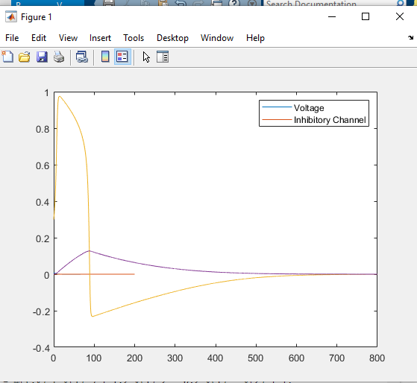

So this behavior is certainly more interesting! What happened?

There’s a voltage spike initially, then it drops quickly below 0 and rebounds to converge with the inhibitory channel. The inhibitory channel shows a slight rise to about 0.125 initially then drops slowly back down towards 0, where it converges with the voltage.

The spike in the voltage means that the neuron has fired. What is the (approximate) peak voltage and approximately how long does the voltage take to drop to its subsequent minimum?

Maximum voltage is approximately 0.968 and drops to its minimum at about t = 95.3.

Now, find the condition for the rate of change of voltage to be equal to zero by setting the first differential equation equal to zero. (You do not have to do algebra to simplify the expression yet)

V^3 -1.2 V^2+ 0.2V = C

This condition becomes a relationship between *V* and *C* (since *I* is zero here). Suppose that *C ≈* 0—then what value(s) of the voltage satisfies this equation? You can solve it by hand, or you could use MATLAB’s symbolic math function *solve* (check the documentation if you need to).

syms(x)

solve (-x^3+1.2*x^2-0.2*x==0) 0, .2, 1

Does your answer to the previous question help explain why you got such different results with initial voltages of 0.1 versus 0.3? How so?

Yes, because the solution space only runs from 0 to 1 – small changes have a big effect because of the cubic and squared terms.

# No neuron is an island

Let’s now consider a more realistic case—we will simulate a neuron that is receiving input signals from other neurons within its network. Recall that given our choice of the Fitzhugh-Nagumo model, we are only studying a single neuron, and the inputs to this neuron from its neighbors are simplified (averaged) to a constant value.

Use a starting voltage of *V* (0) = 0*.*1 and run your simulation until *t* = 2000. Assume that the channels are **completely closed** at the start of your simulation—what does this mean *C*(0) should be?

Completely closed would be C=0.

In this section you are going to see how your results change for different values of the input signal, *I*. Perform at least five simulations, varying *I* between a minimum value of 0.02 and a maximum value of 0.2. Produce plots showing both *V* and *C* versus time for each of these simulations, and describe generally what happens as you increase the input signal.

As input increases, there’s first a single voltage spike, at higher and higher peaks, until somewhere between 0.1 and 0.15, multiple spikes appear at increasing peak voltages up to 0.2.

Paste below a screenshot of your plot for *I* = 0*.*2.

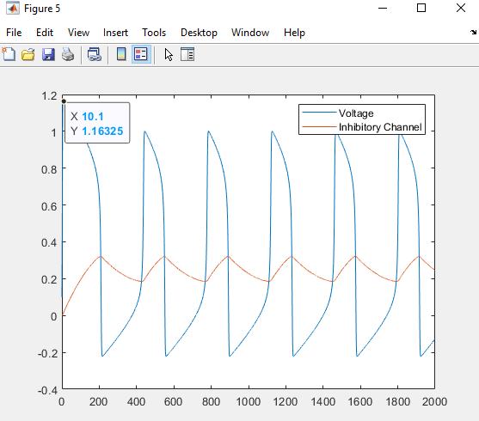

Comment on the difference between what happens for *I* = 0*.*1 and *I* = 0*.*2.

At 0.1, we see a single voltage spike, while at 0.2, we see multiple voltage spikes at higher peak levels.

We call the pattern that you see for *I* = 0*.*2 a “spike train.” What is the approximate amount of time separating each spike?

Roughly 335 (msec?)

You may have noticed that *C*(*t*) has a maximum at points that intersect with the *V* (*t*) curve. By looking at the differential equation for *C* and using what you know about the derivative of a function at a maximum, explain why this makes sense.

dC/dt = .002(V-C). At maximum, derivative = 0, so at that point, V=C.

You also may have noticed that the first voltage peak is a bit higher than all of the other peaks. Looking now at the differential equation for *V* and using similar reasoning to the question that you just answered, why would you expect the maximum value of voltage to be higher here? (Hint: think about the initial condition for *C*.)

C acts as an inhibitor of V, so if C=0, there’s no inhibition and V is maximal.

# State space and nullclines

We can get more insight into the oscillatory behavior by exploring the system in state space. Move to the next block in the provided m-file, which contains the code to generate a vector field for the model.

Run the first block to set up the model and generate a vector field.

Now, we will overlay the **nullclines** on the same plot. As we discussed briefly in lecture, the nullclines are the curves on which one of the derivatives is equal to zero.

Working with the general model differential equations, find the equation of the curve on which dC/dt = 0. Write the equation in the form of C = (expression depending on V). Write the equation below.

C = V

Now solve the equation for the curve on which dV/dt = 0. Again, write the equation in the form of C = (expression depending on V). Write the equation below.

C = -V^3 + 1.2V^2 - 0.2V + I

Edit the last block to plot these two curves on the same graph you generated above. Paste a screenshot of your plot below.

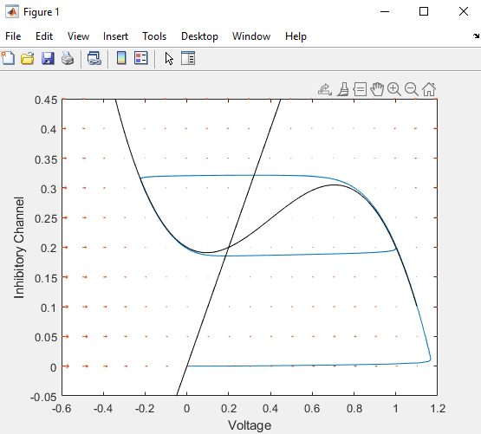

Examine the plot closely, and describe how the path of the trajectory relates to the nullclines.

Nullclines are partially overlaid on the trajectory, such that the top of the trajectory forms a bounding box around the parts of the dV/dt nullcline where it changes direction.

One key to understanding this behavior is to think about the different scales of the two derivatives. In the vector field plot, which directions do the arrows appear to be pointing. Can you understand this in terms of the differential equations?

They’re all horizontal, pointing to the right from the far left to where dV/dt = 0, at which point they change direction and point to the left. Everything seems to converge on the dV/dt nullcline.